**REPORT**

Zajęcia: Analog and digital electronic circuits

Teacher: prof. dr hab. Vasyl Martsenyuk

**Lab 1**

Date: 11.10.2025

Topic: " Discrete-time signal synthesis using the Inverse Discrete Fourier Transform (IDFT) in matrix notation. Visualization of W and K matrices and time-domain signal reconstruction"

Variant: All given xₘ vectors (10 variants)

Artur Rolak

Informatyka II stopień,

stacjonarne,

2 semestr,

Gr. 1b

1. **Problem statement:**

**The goal of this laboratory exercise was to synthesize discrete-time signals using the Inverse Discrete Fourier Transform (IDFT) written in matrix form.  
The task required:**

**building matrices K and W according to their mathematical definitions,**

**reconstructing the signal $x[k]=\frac{1}{N}Wx_{μ}$ for different $N$,**

**displaying both matrices $W$ and $K$,**

**and plotting the synthesized discrete-time signals for the given input vectors $x_{μ}$.**

**This exercise aimed to deepen understanding of the relationship between the frequency and time domains in digital signal processing and how the Fourier matrix enables inverse spectral reconstruction.**

1. **Input data:**

**The following input vectors $x_{μ}$ were provided for different values of $N$:**

$$\begin{matrix} & [6,2,4,3,4,5,0,0,0,0]^{T}, \\ & [10,5,6,6,2,4,3,4,5,0,0,0,0]^{T}, \\ & [6,2,4,3,4,5,0,0,0,0]^{T}, \\ & [6,2,4,3,4,5,0,0,0]^{T}, \\ & [6,4,4,5,3,4,5,0,0,0,0]^{T}, \\ & [7,2,4,3,4,5,0,0,0,0]^{T}, \\ & [6,8,2,4,3,4,5,0,0,0]^{T}, \\ & [6,2,4,4,4,5,0,0,0,0]^{T}, \\ & [6,5,4,3,4,5,0,0,0,0]^{T}, \\ & [6,2,4,3,4,4,0,0,0,0]^{T}.\end{matrix}$$

**Each vector defines a frequency-domain representation of a discrete signal.  
The length $N$ of each vector determines the dimension of matrices $K$ and $W$.**

1. **Commands used (or GUI):**
2. source code

**The code was implemented in** Python **within** JupyterLab **(Anaconda environment).  
Libraries used: numpy, matplotlib.**

**Key formulas implemented:**

$$K=k⋅μ^{T},W=e^{j\frac{2π}{N}K},x[k]=\frac{1}{N}Wx_{μ}$$

1. screenshots

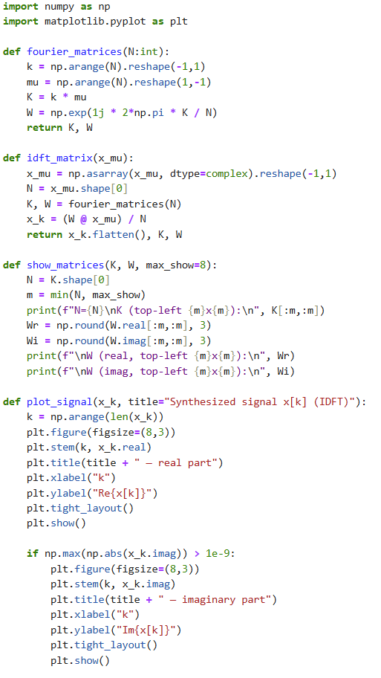

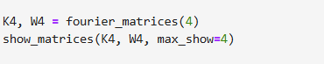

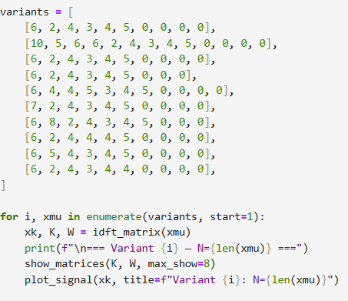

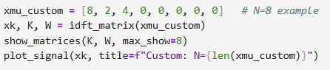

Link to remote repozytorium (e.g. GitHub)

**4. Outcomes:**

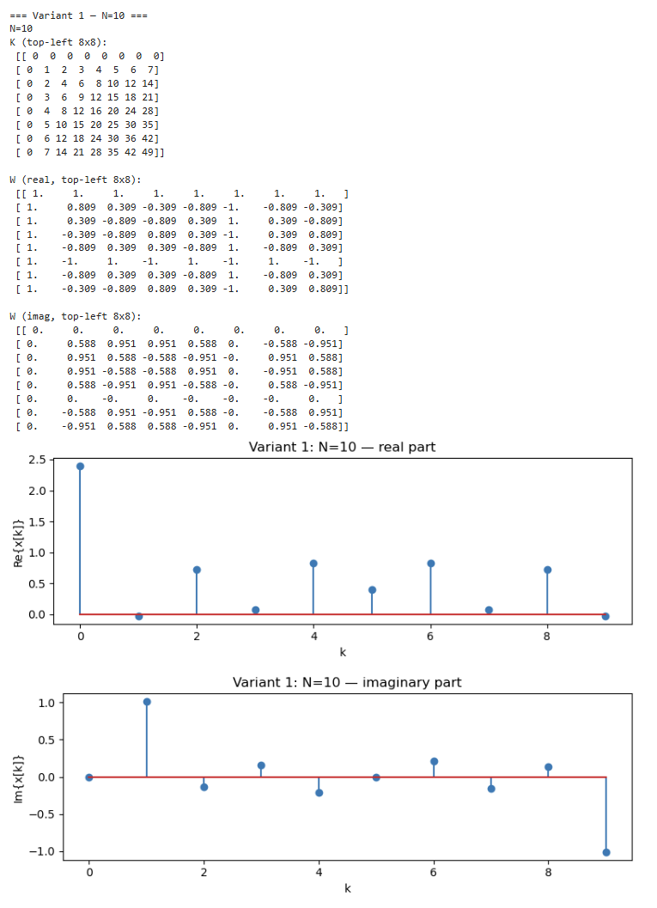

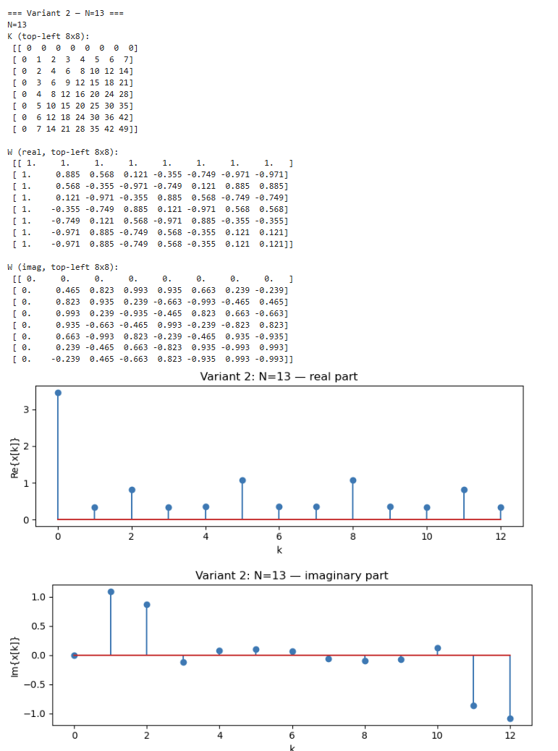

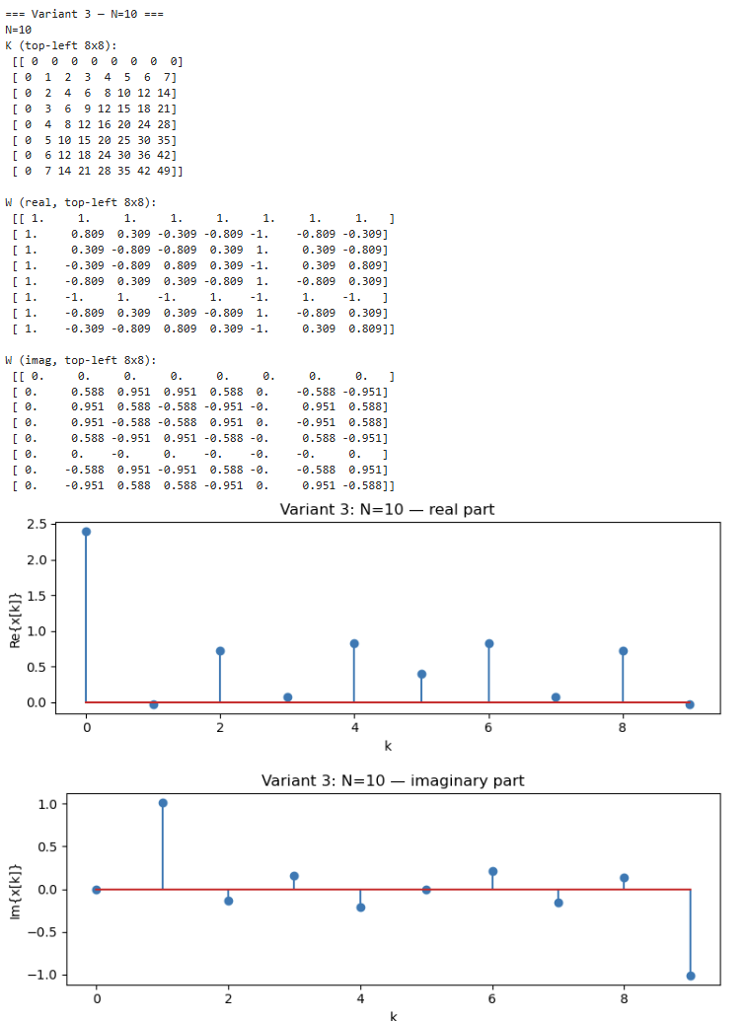

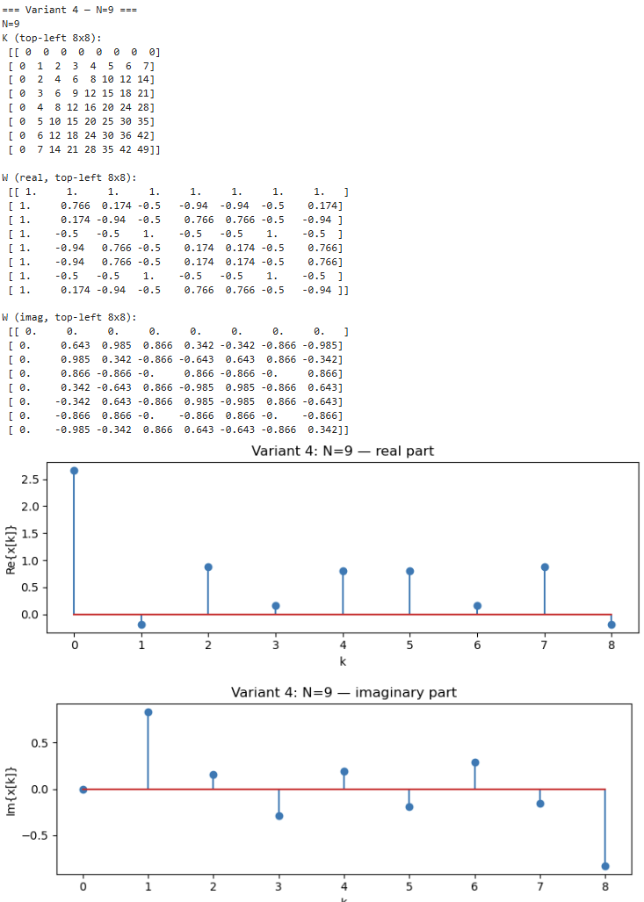

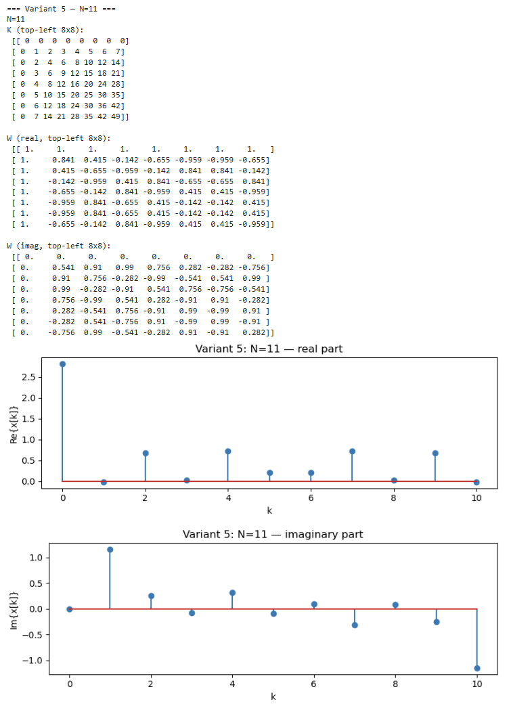

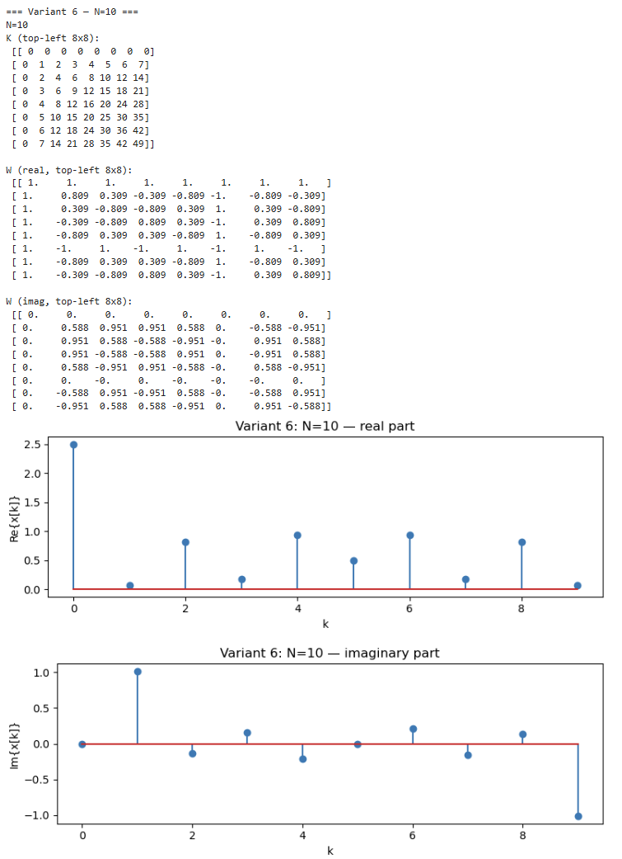

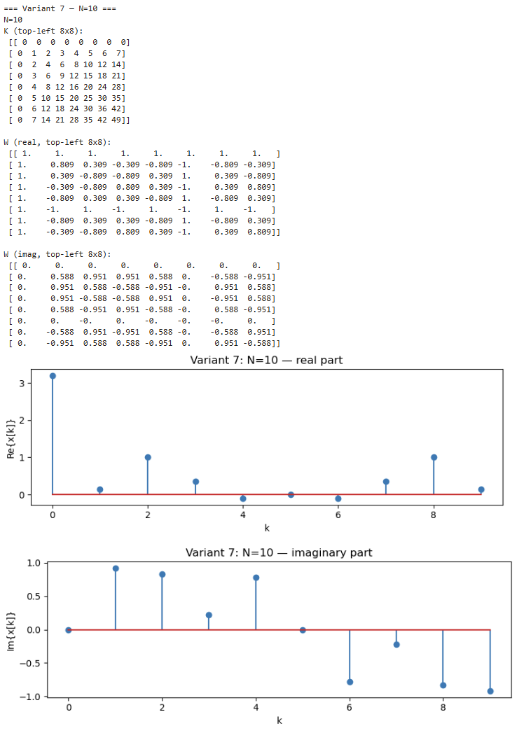

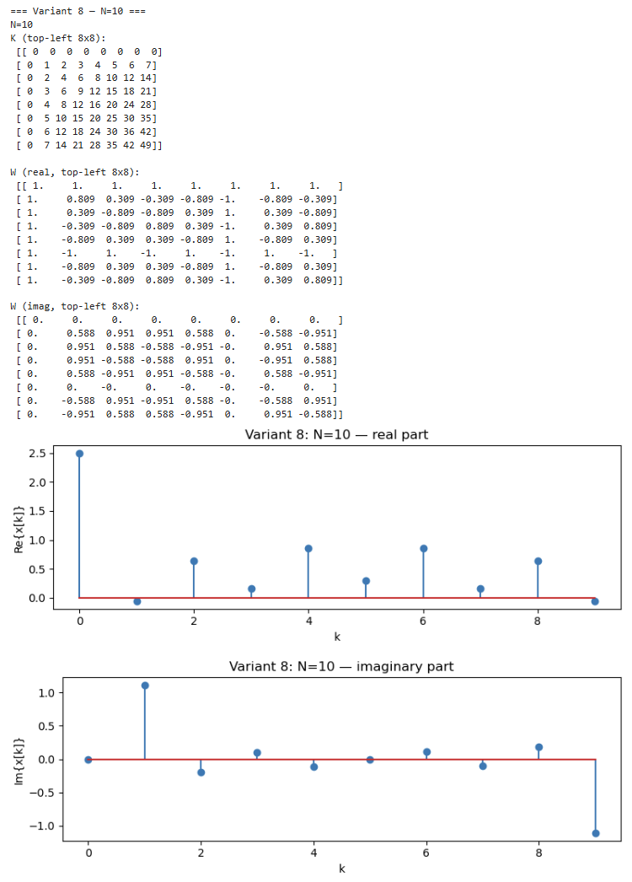

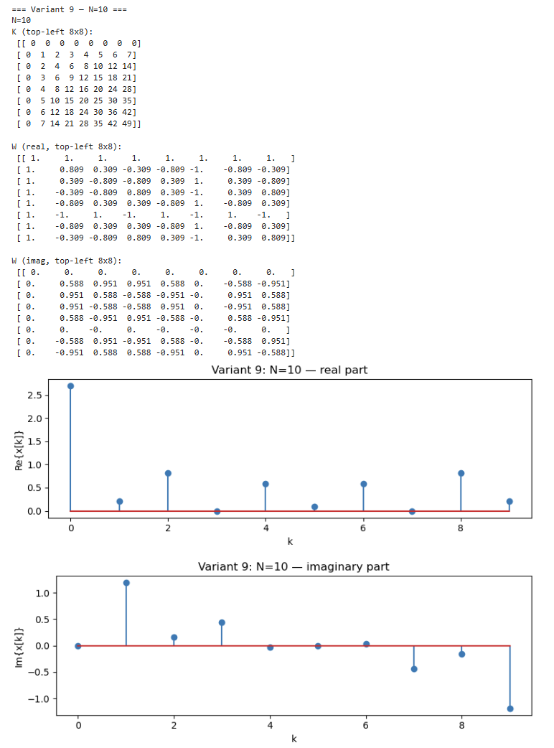

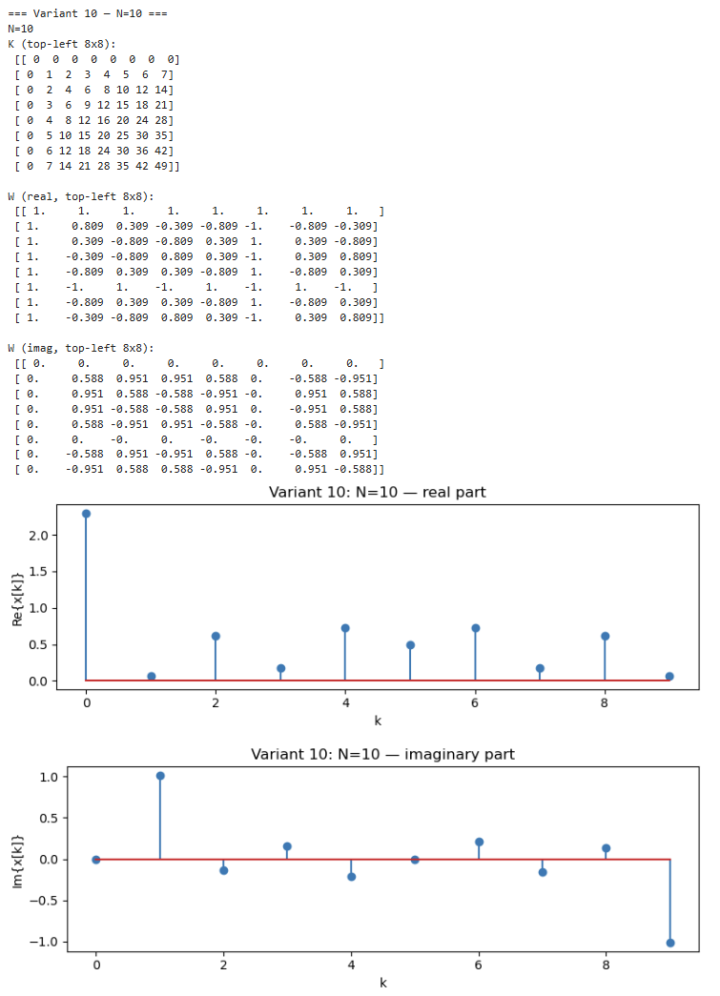

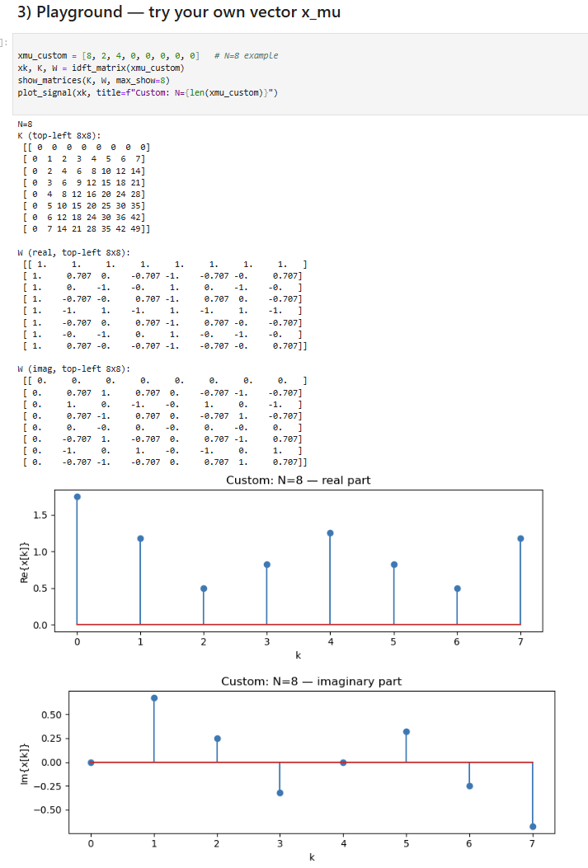

1. **Conclusions:** For the reasons given, we conclude that:

**The experiment confirmed that the IDFT in matrix notation accurately reconstructs discrete-time signals from their spectral representations.  
The matrices $K$ and $W$ play a crucial role in connecting the frequency and time domains:**

$K$**defines the frequency-time index mapping,**

$W$**represents the complex exponential basis vectors.**

**For different $N$, the synthesized signals show distinct resolutions and sampling effects, demonstrating how IDFT converts frequency coefficients into time-domain samples.**

**Therefore, we conclude that the matrix formulation of IDFT is a valid and efficient approach to understand the mathematical structure of the Fourier transform and signal reconstruction in DSP.**